Assignment
Aim : To create a user intractive website using frontend(CSS , HTML and JAVASCRIPT).
Program:
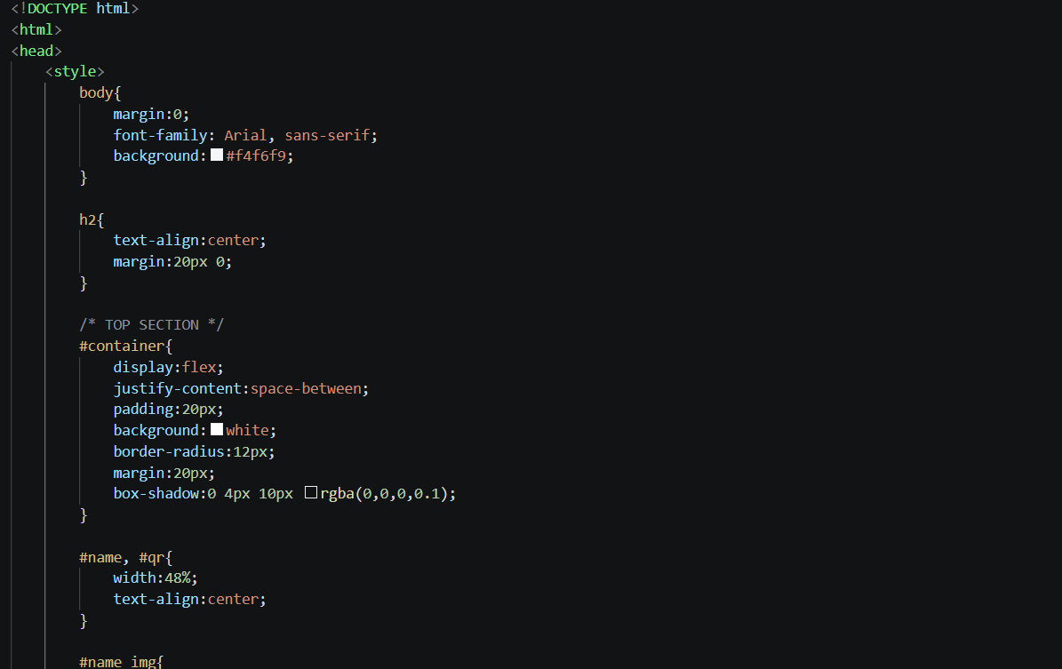
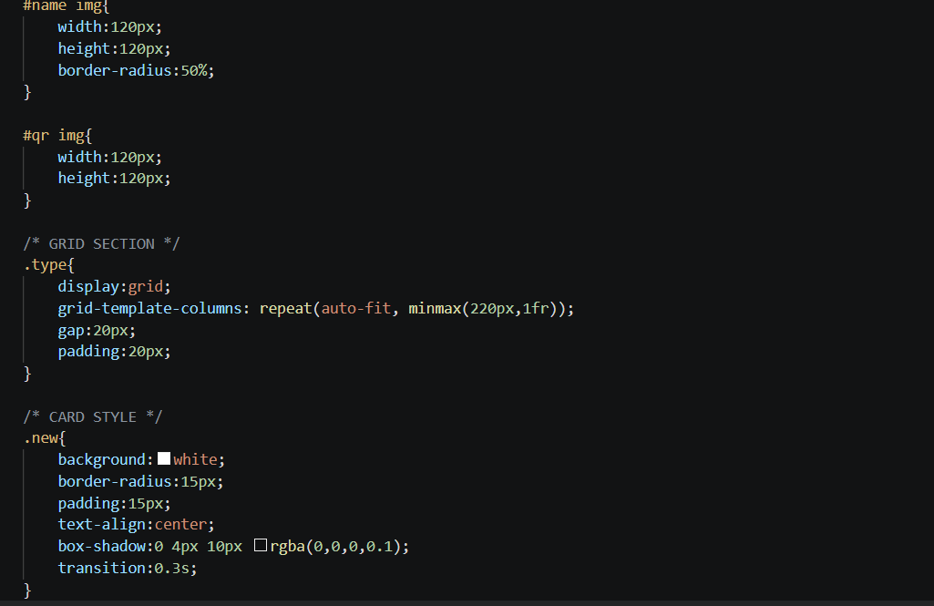
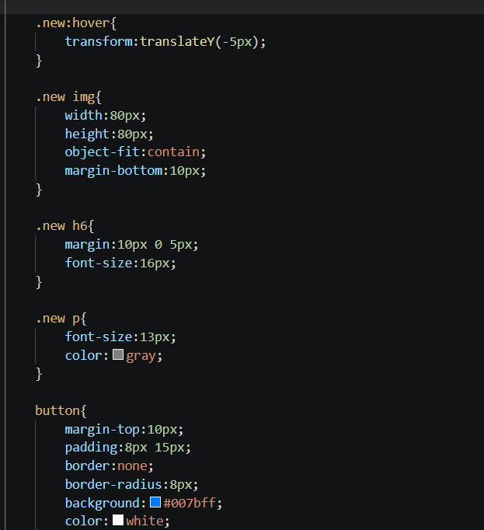
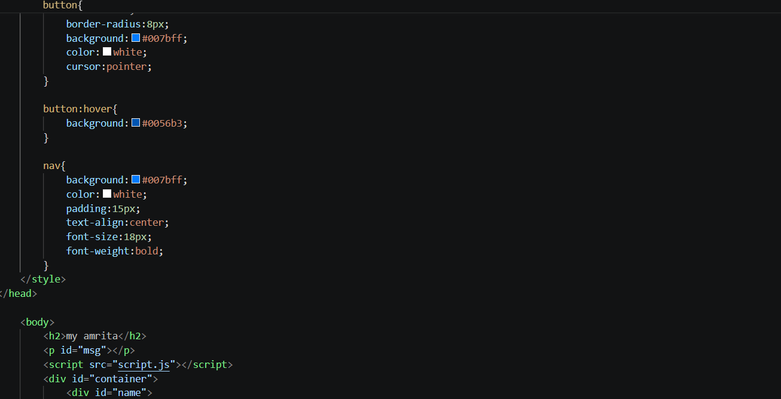
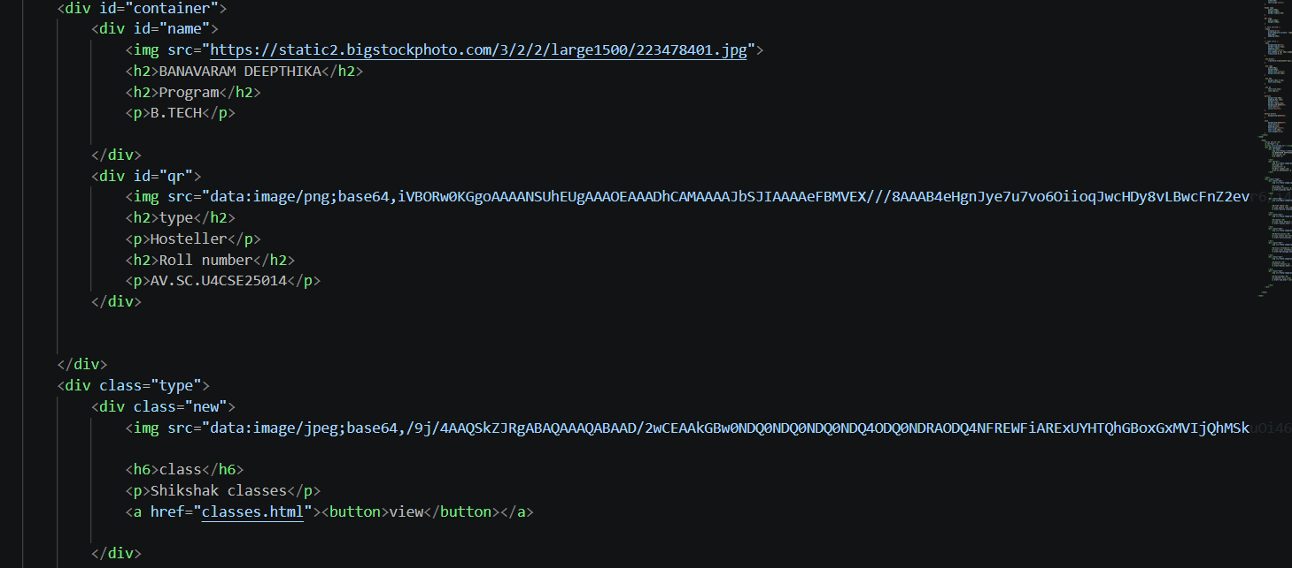
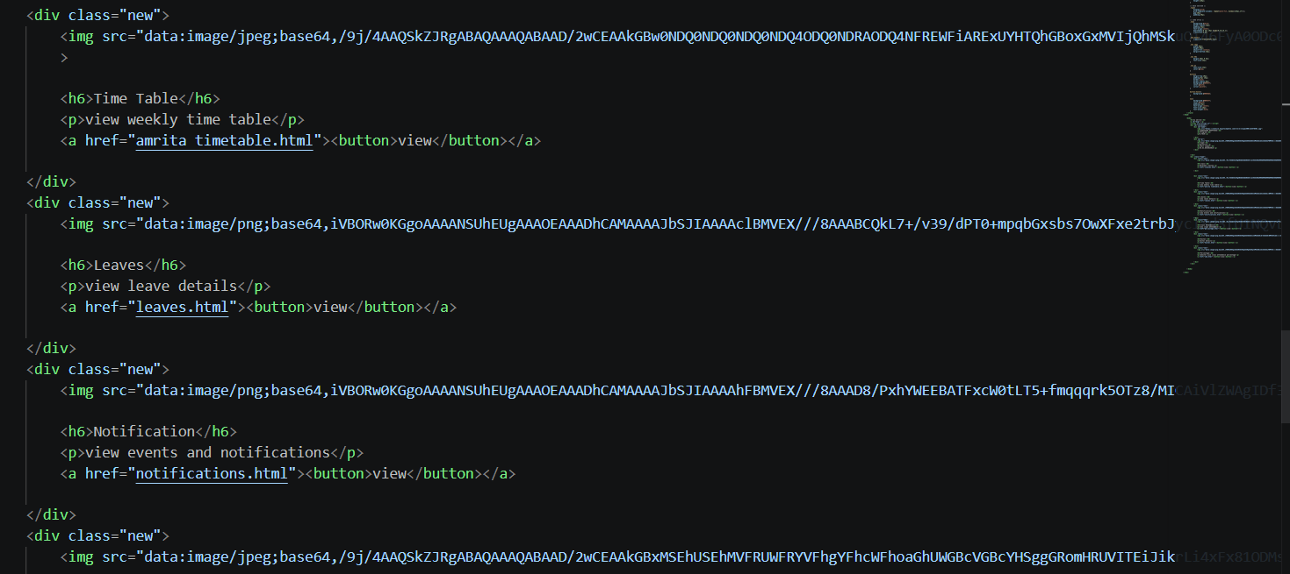
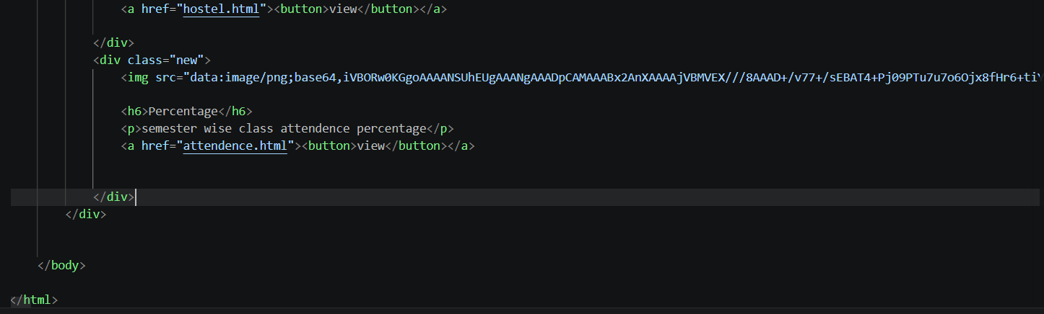

Leaves:
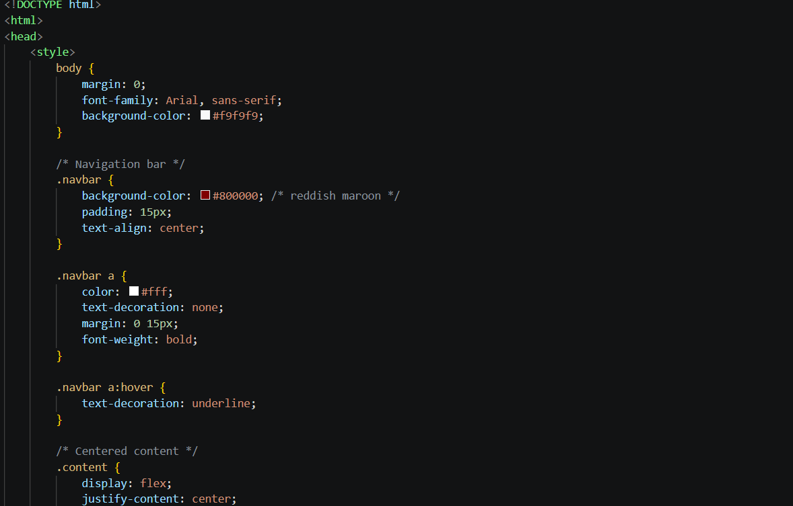
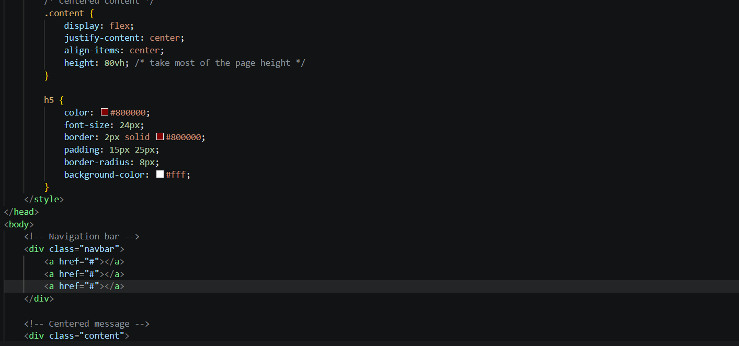
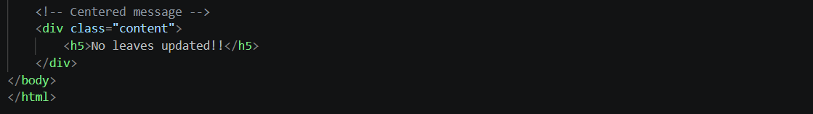
Shikshak Classes:


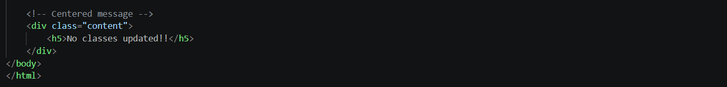
Notifications:
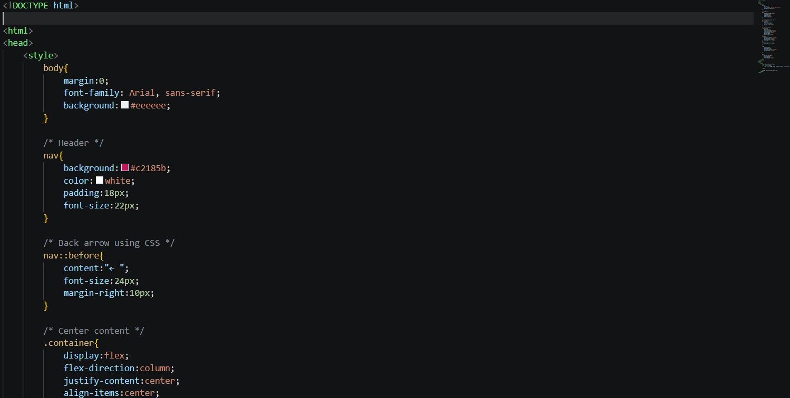
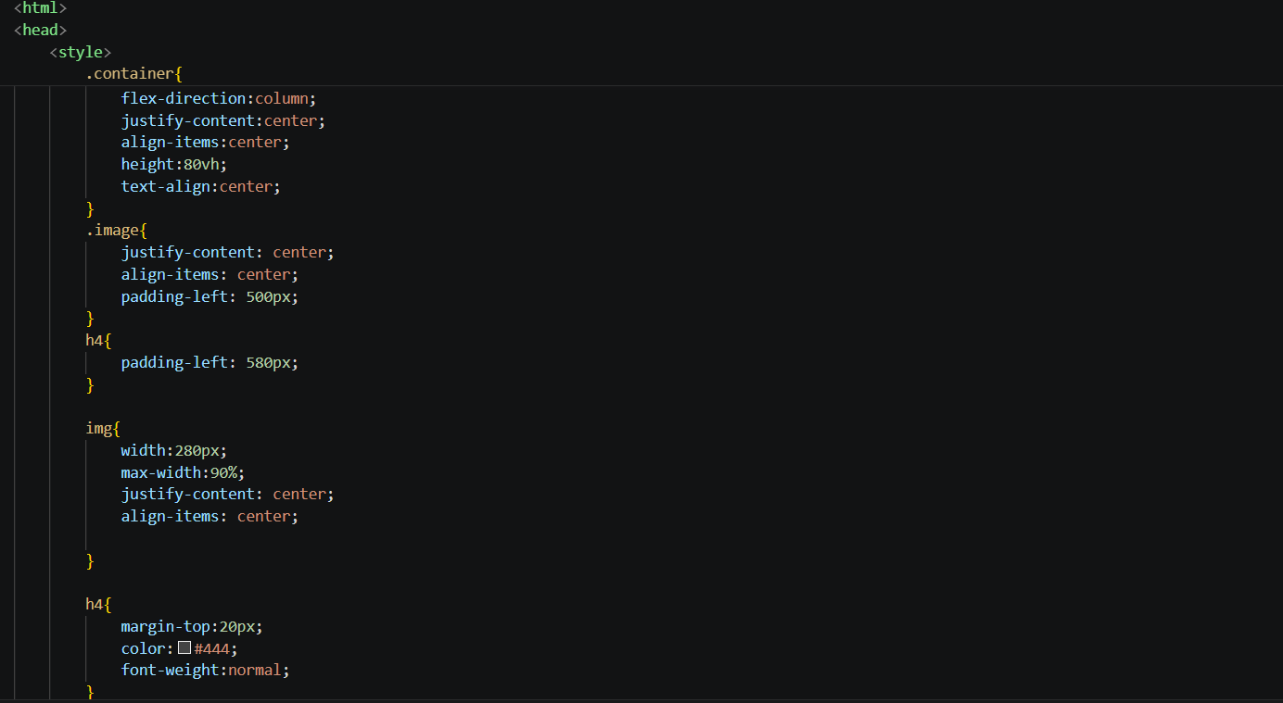
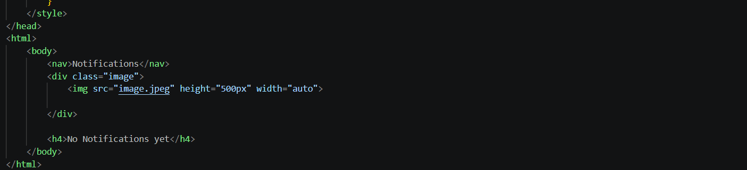
Time Table:
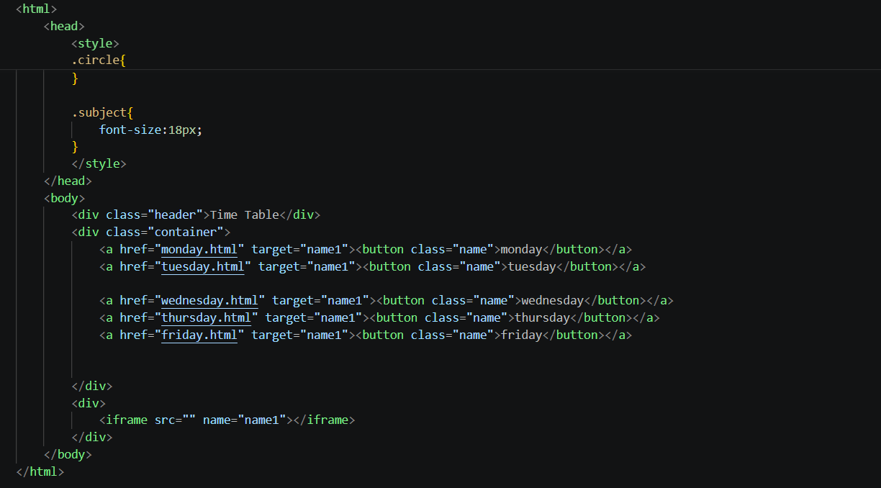
Class Attendence:
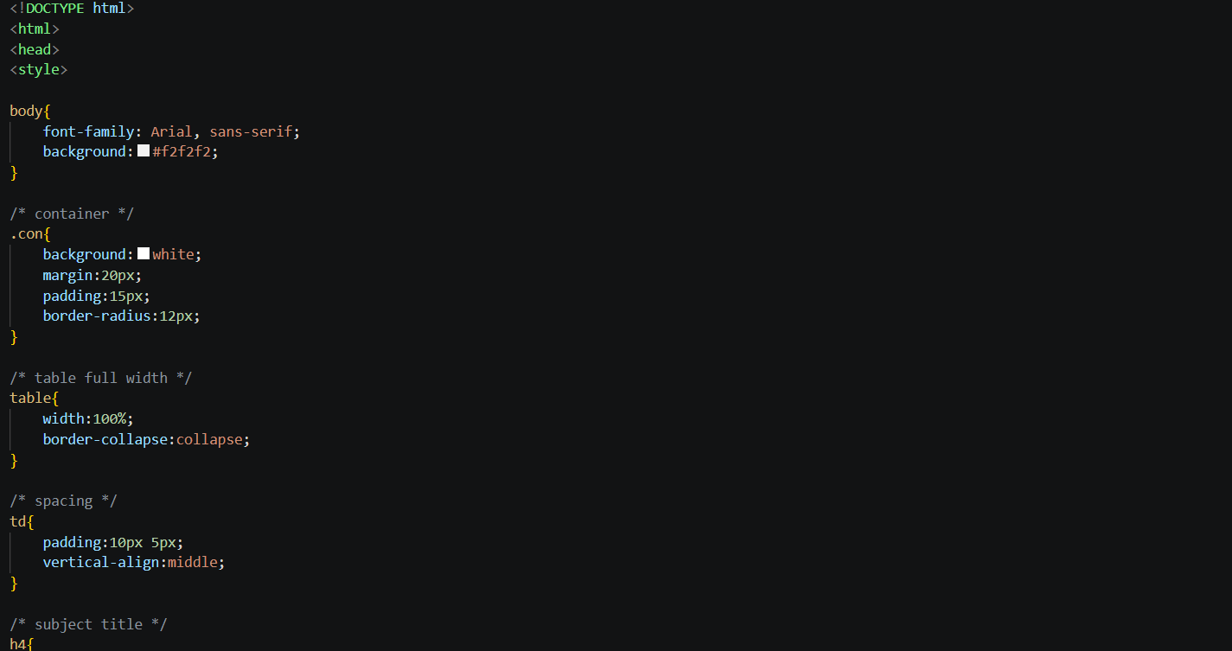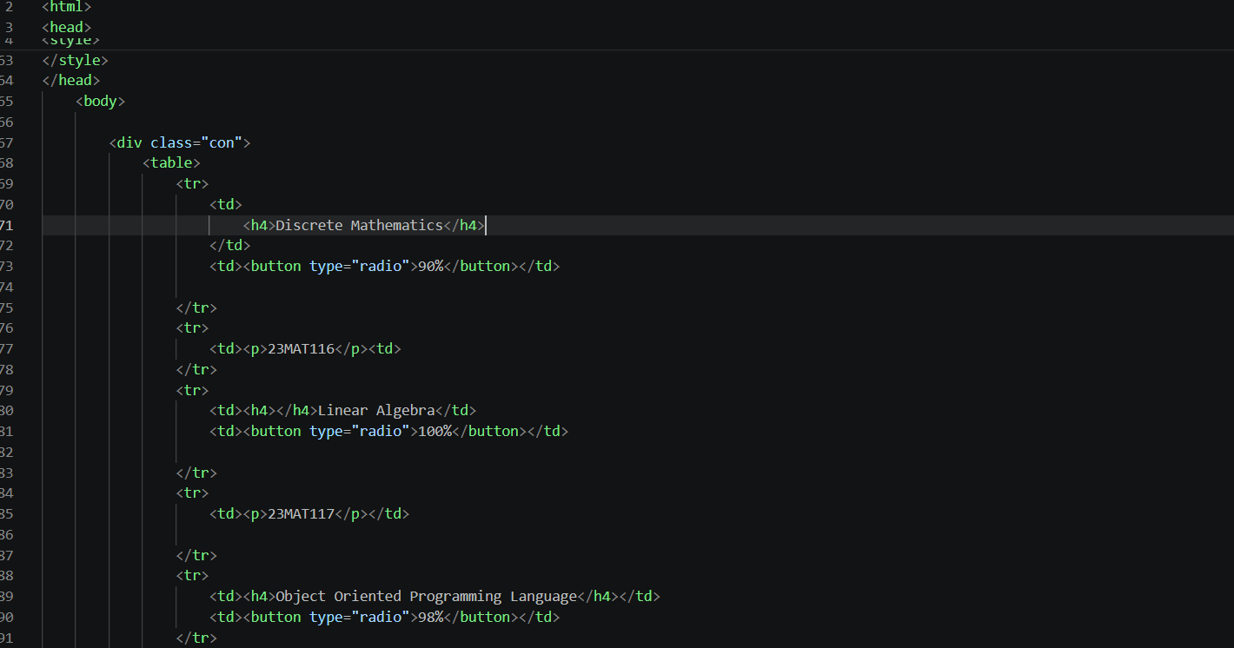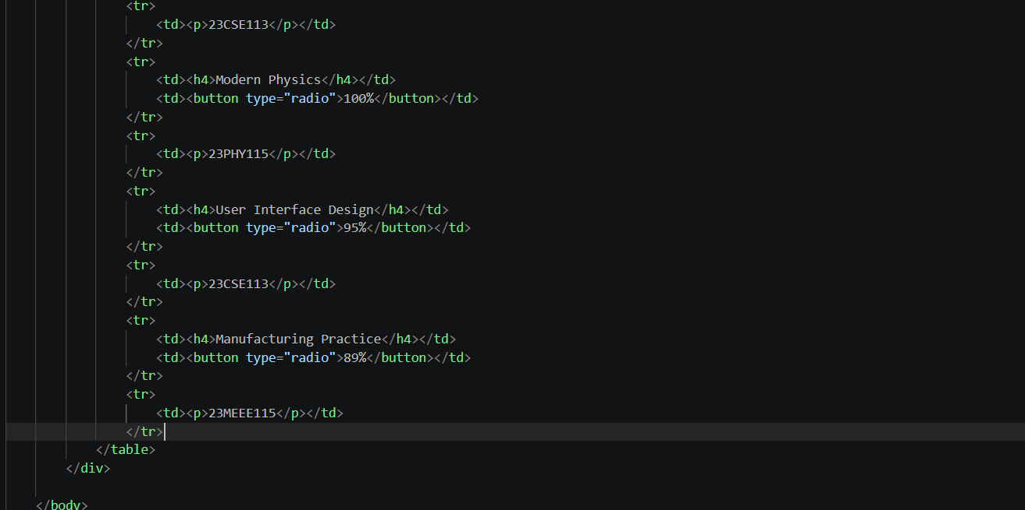
Hostel:
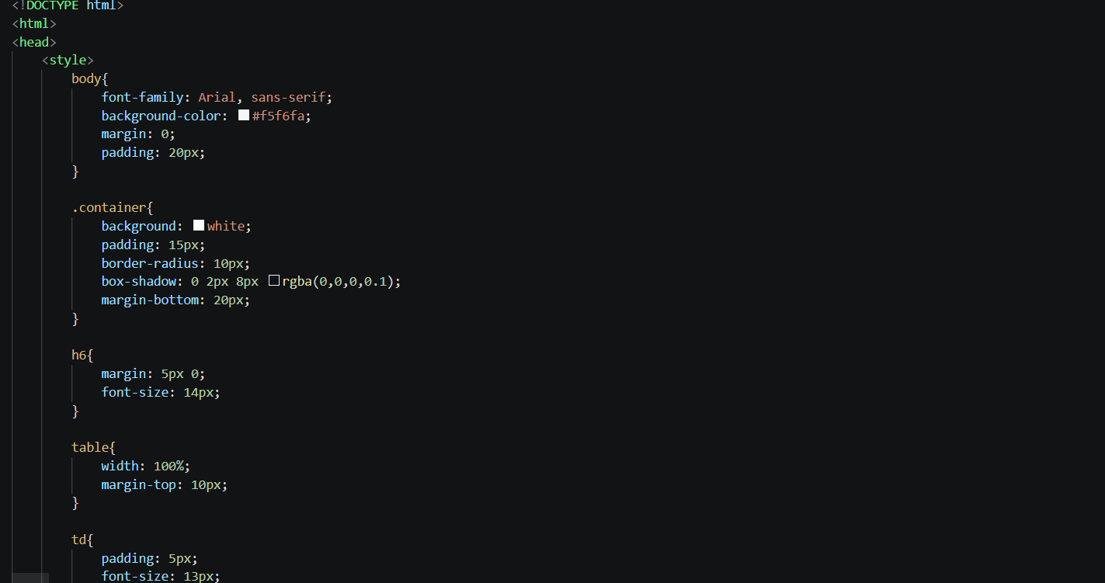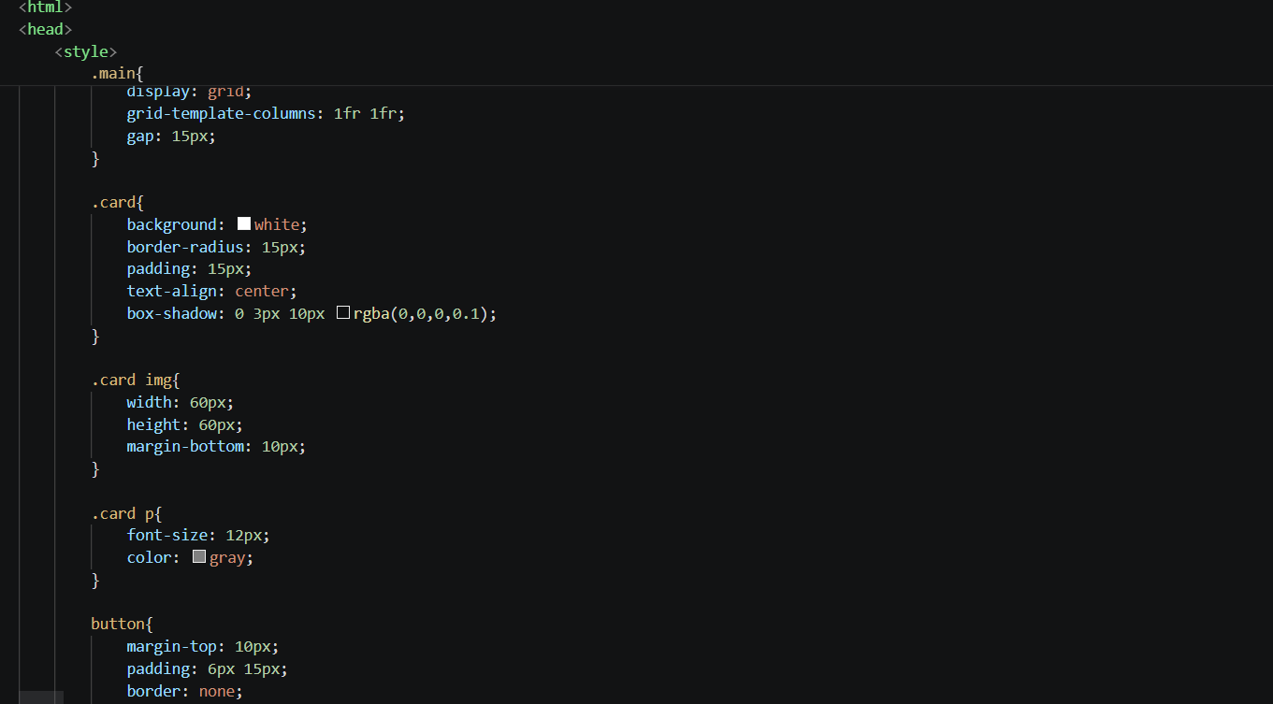
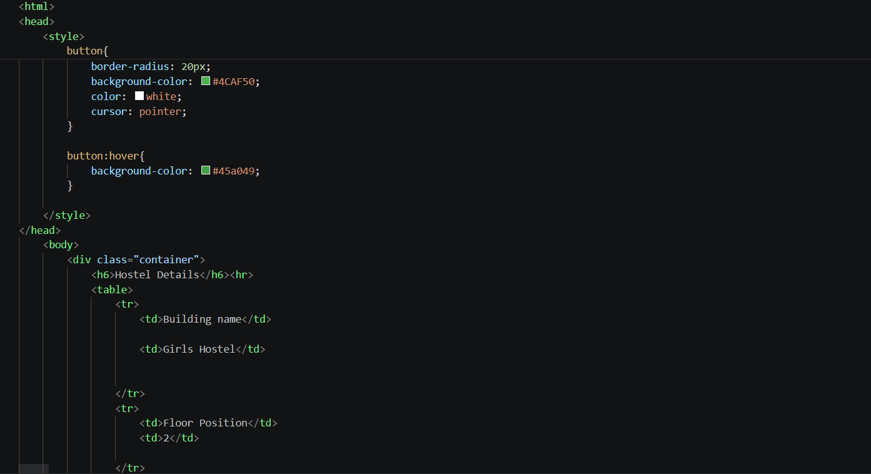
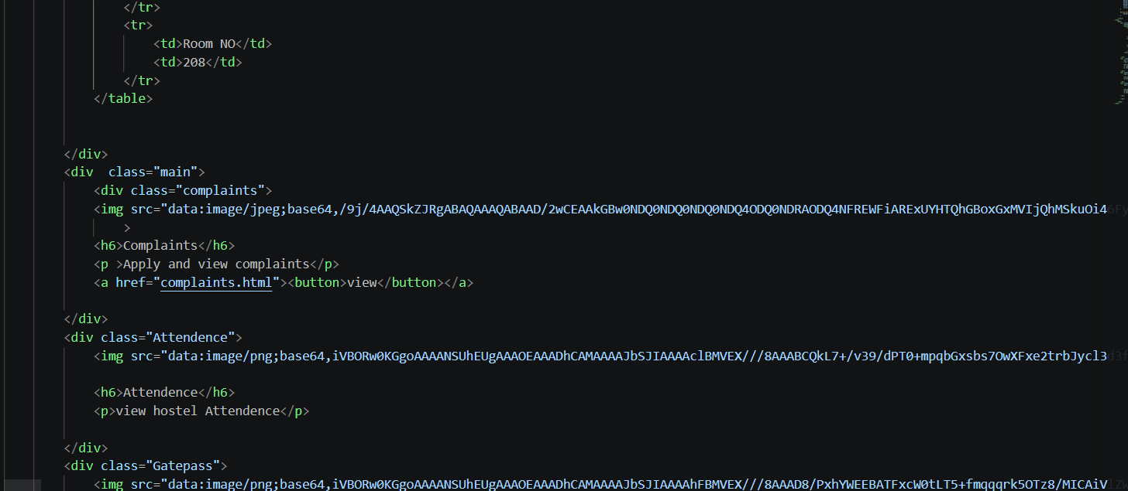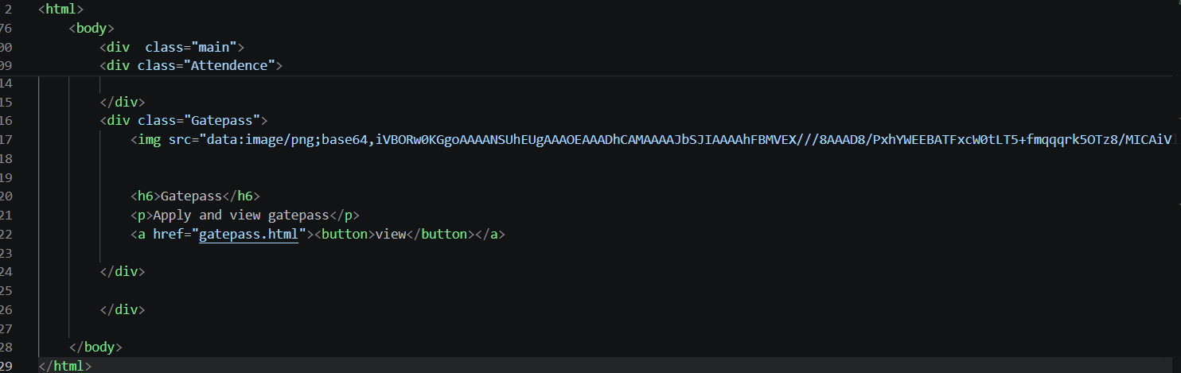
Complaints:
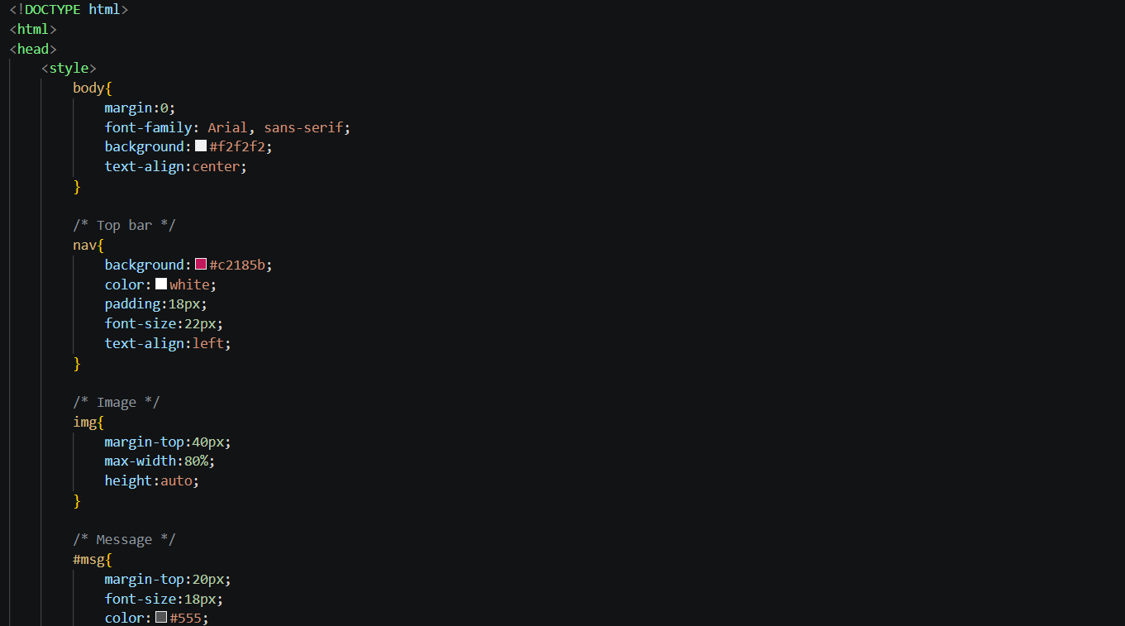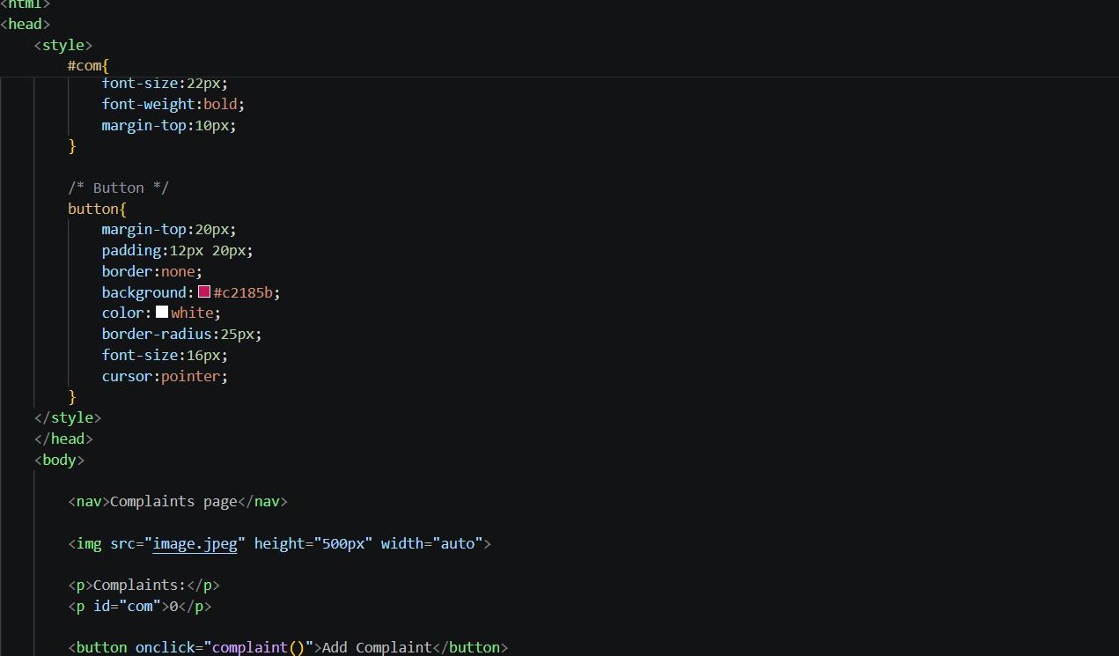
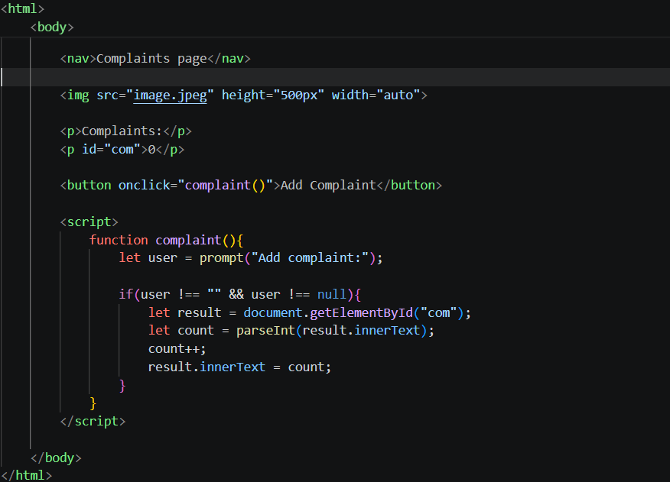
GatePass:
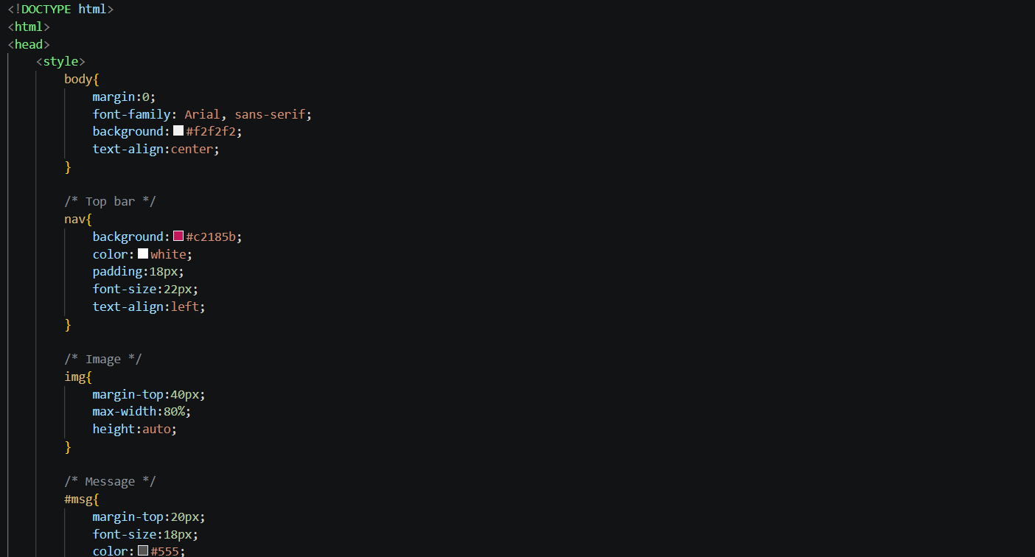
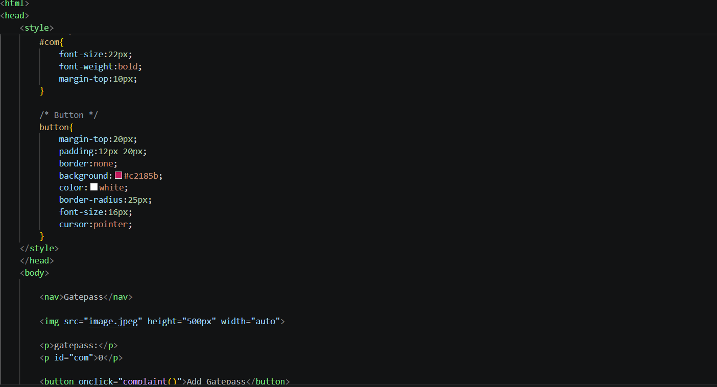
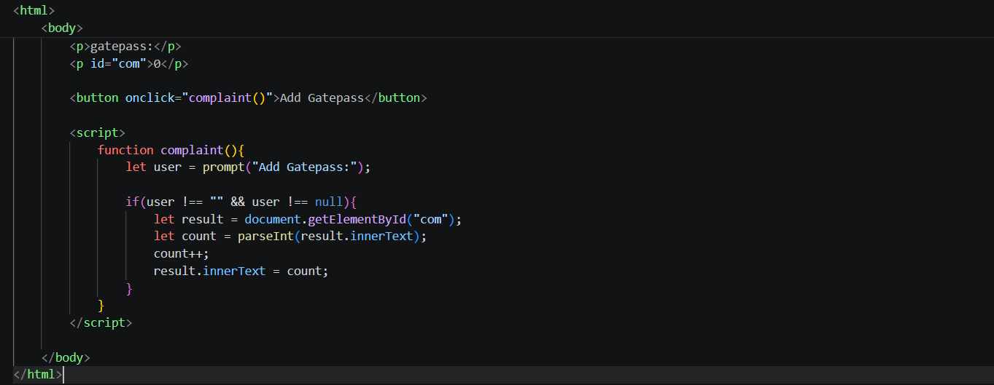

Output:
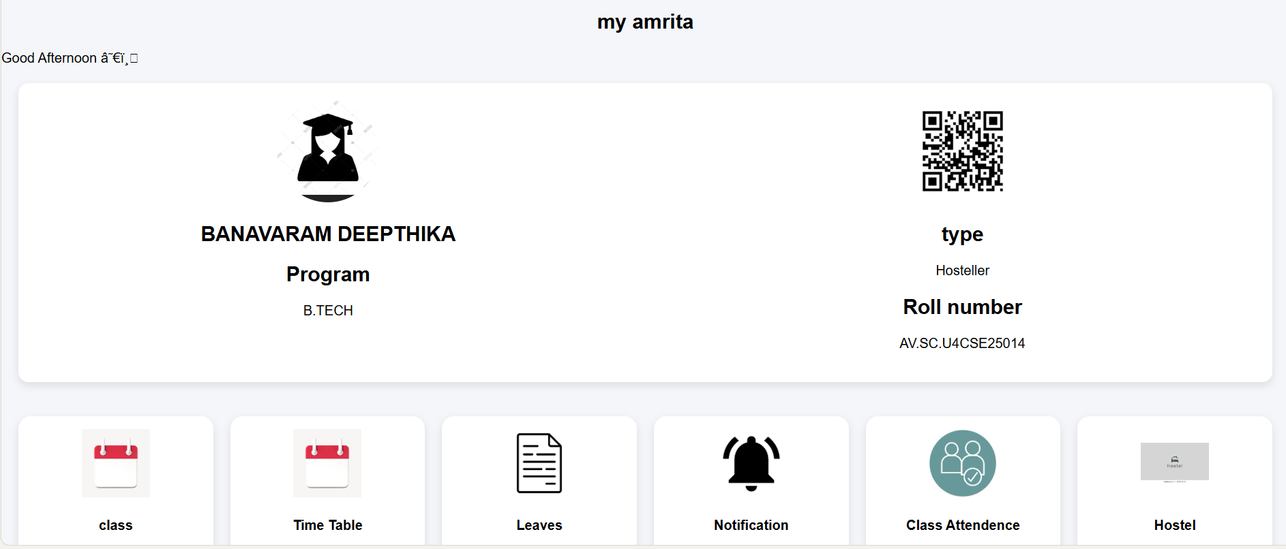
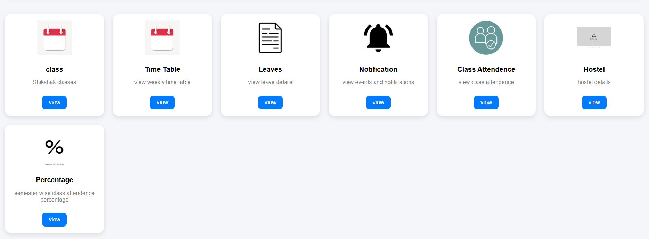

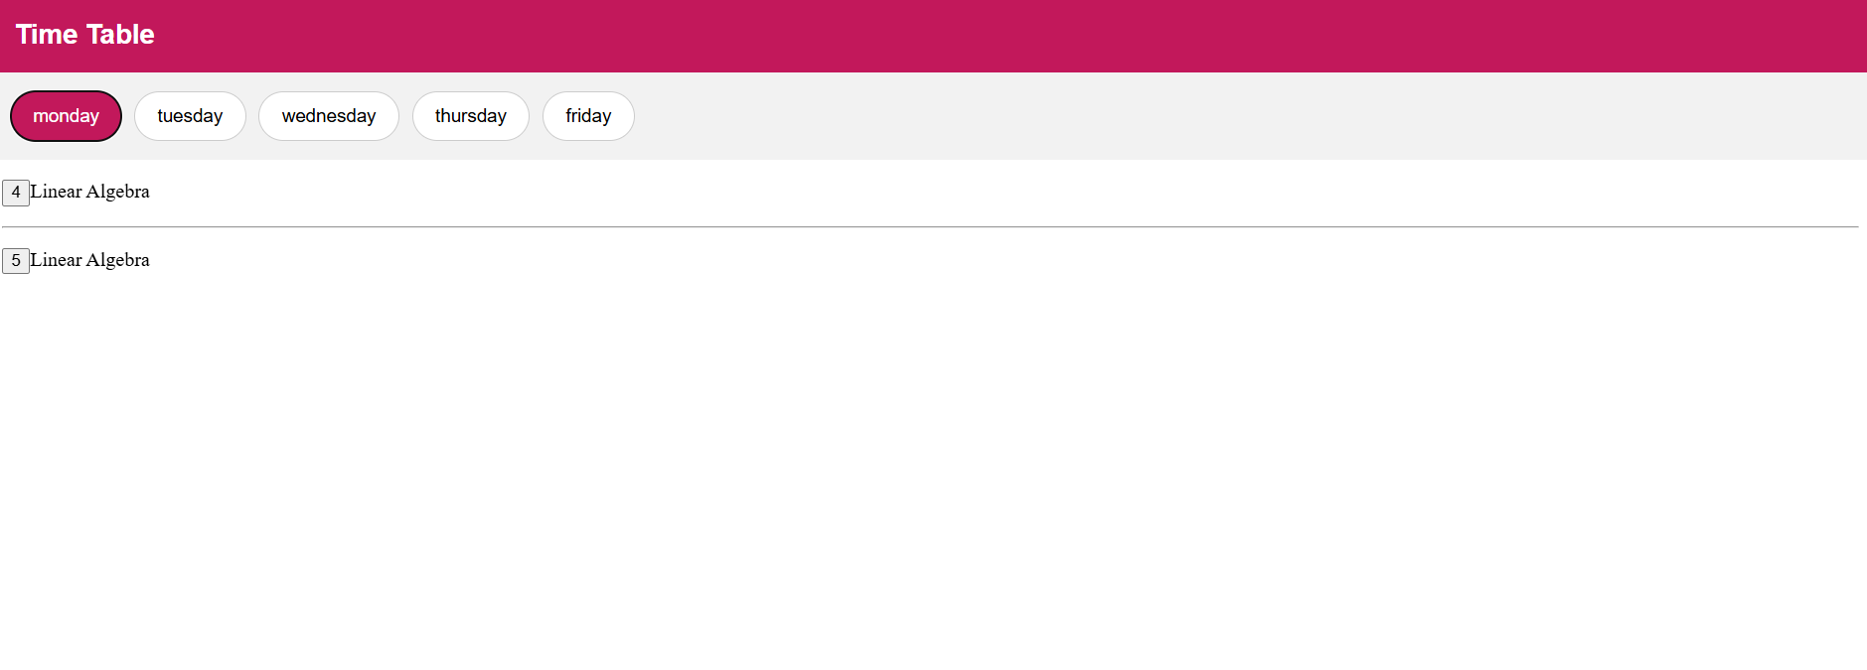


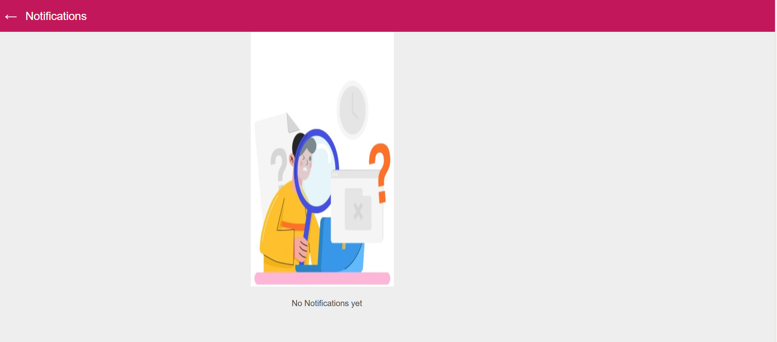
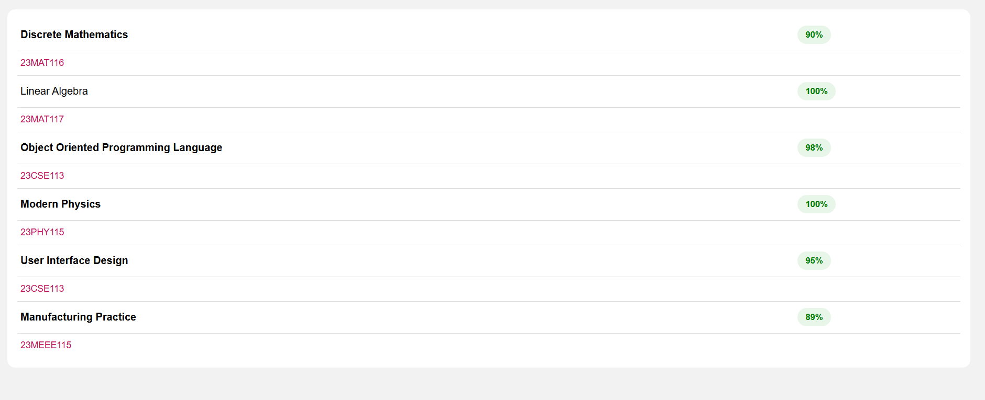
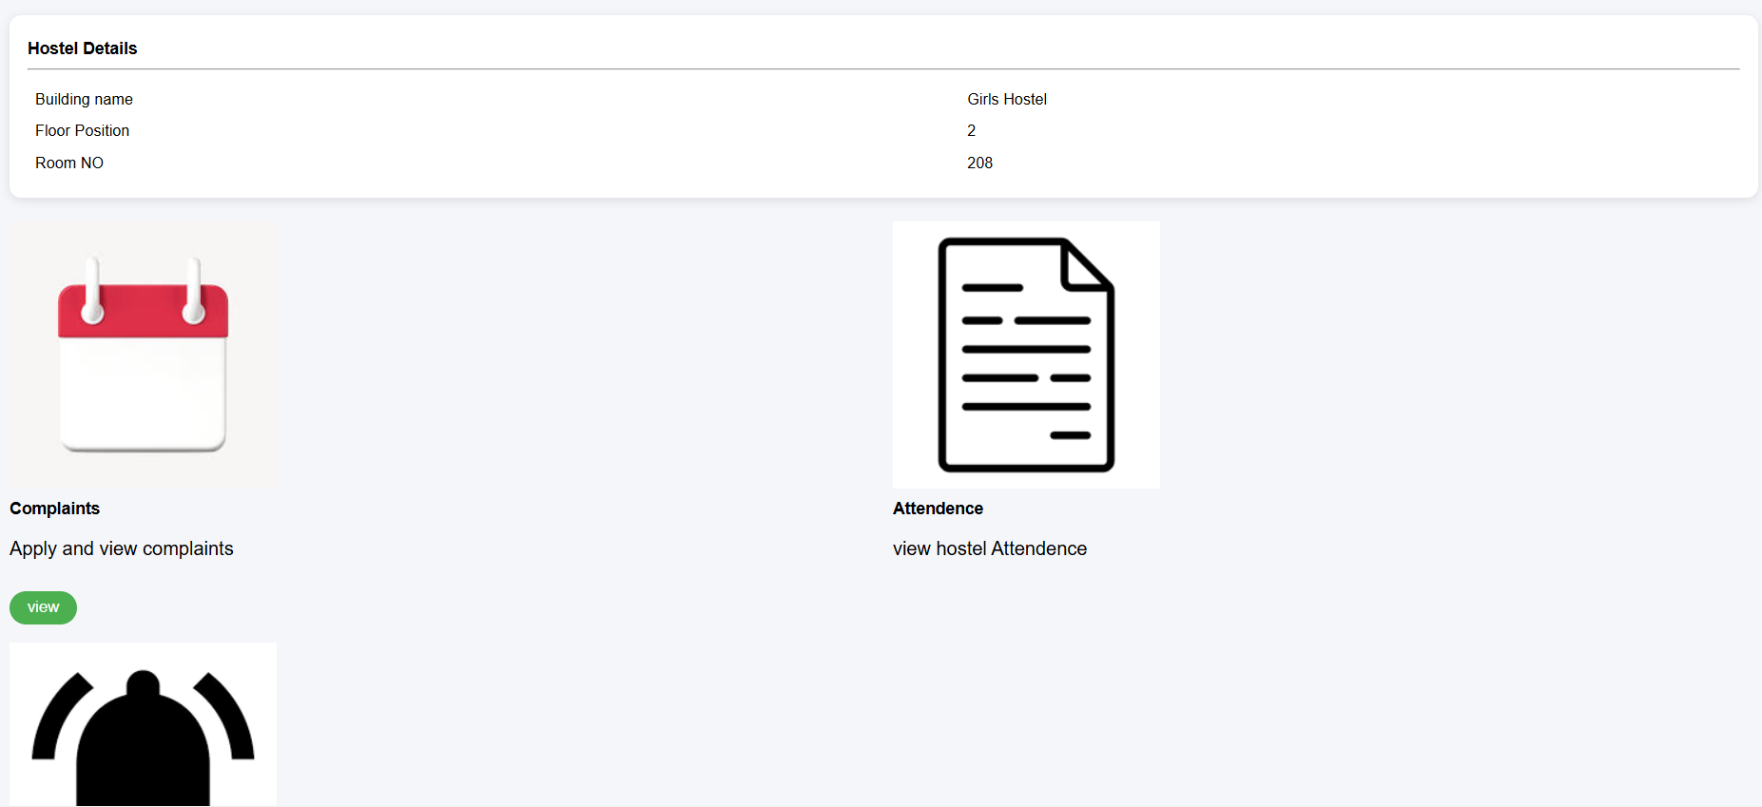

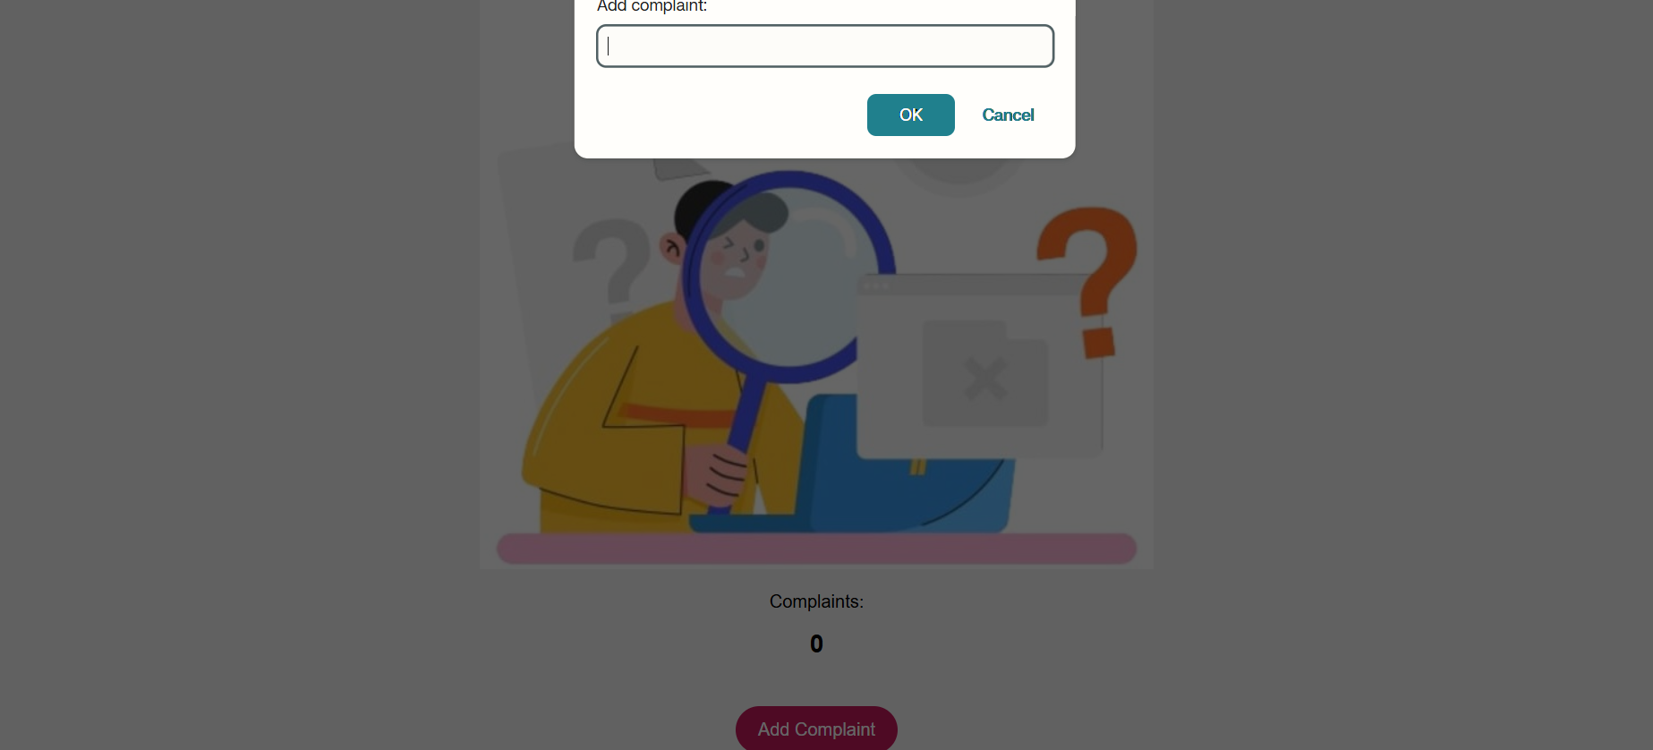
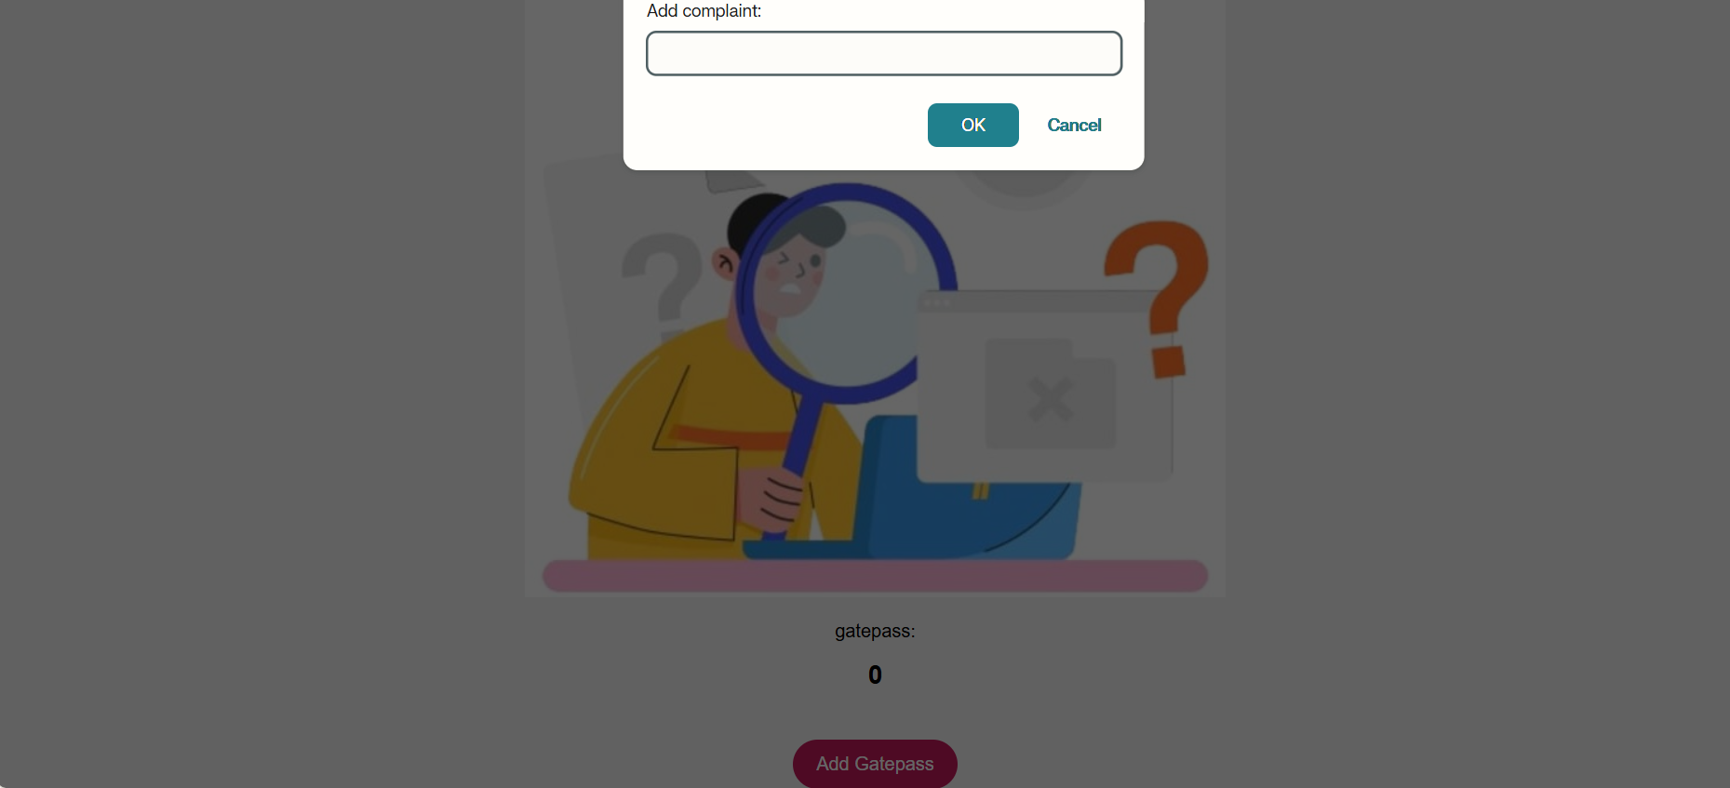

Explanation of tags:
The developed project is a frontend-based interactive student management website created using HTML, CSS, and JavaScript.
The website contains multiple modules such as Leaves, Notifications, Attendance, Timetable, Hostel, Complaints, and Gate Pass.
The purpose of this project is to demonstrate how frontend technologies work together to create an interactive, user-friendly, and dynamic web application.
In this project, every tag, property, method, and function contributes either to the structure, appearance, navigation, or interactivity of the webpage.
The following section explains the purpose of the important elements and also describes how they affect the behaviour of the webpage and the concepts involved in their implementation.
=====================================================================
1. WEBPAGE STRUCTURE AND ORGANIZATION
=====================================================================
The HTML structure of the project is responsible for organizing webpage content into different sections.
The webpage is divided into modules such as attendance, timetable, notifications, and complaints to improve readability and navigation.
---------------------------------------------------------------------
USE OF <div> TAG
---------------------------------------------------------------------
The <div> element is used throughout the project as a container to group related webpage elements together.
Purpose in the Project:
• Organizes webpage sections properly.
• Separates modules like attendance, complaints, and notifications.
• Helps apply CSS styling to an entire section at once.
Effect on the Webpage:
• Creates a clean webpage layout.
• Maintains proper spacing and alignment.
• Makes the interface more structured and readable.
Concept Involved:
Container-based webpage structuring and layout management.
Importance:
Without div containers, managing large webpages becomes difficult because styling and positioning elements individually increases complexity.
---------------------------------------------------------------------
USE OF HEADINGS (<h1>, <h2>, etc.)
---------------------------------------------------------------------
Heading tags are used to display titles and section names.
Purpose:
To create proper hierarchy and identify different webpage sections clearly.
Effect on the Webpage:
• Highlights important content.
• Improves readability.
• Makes navigation easier for users.
Concept Involved:
Semantic webpage organization and content hierarchy.
Importance:
Headings improve user understanding and create a professional webpage structure.
---------------------------------------------------------------------
USE OF TABLES
---------------------------------------------------------------------
Tables are used in modules such as Attendance and Timetable.
Purpose:
To display information in rows and columns.
Effect on the Webpage:
• Organizes data systematically.
• Improves readability of schedules and attendance records.
• Makes information comparison easier.
Concept Involved:
Structured data representation.
Importance:
Tabular representation helps users understand large amounts of information clearly.
=====================================================================
2. CSS STYLING AND USER INTERFACE DESIGN
=====================================================================
CSS is responsible for improving the visual appearance and user experience of the website.
Without CSS, the webpage would display plain content without proper design, spacing, alignment, or responsiveness.
---------------------------------------------------------------------
USE OF COLORS
---------------------------------------------------------------------
Different background and text colors are applied throughout the project.
Purpose:
To improve webpage appearance and highlight important sections.
Effect on the Webpage:
• Creates attractive interface design.
• Improves readability.
• Makes sections visually distinguishable.
Concept Involved:
User Interface (UI) design and visual communication.
Importance:
Proper color usage improves user engagement and creates a professional appearance.
---------------------------------------------------------------------
USE OF PADDING AND MARGIN
---------------------------------------------------------------------
Padding and margin are used to create spacing around webpage elements.
Purpose:
To avoid overcrowding of content.
Effect on the Webpage:
• Creates clean spacing.
• Improves readability.
• Maintains organized layout structure.
Concept Involved:
CSS Box Model.
Importance:
Spacing improves webpage clarity and user experience.
---------------------------------------------------------------------
USE OF BORDER AND BORDER-RADIUS
---------------------------------------------------------------------
Borders are applied to buttons, tables, and content sections.
Purpose:
To visually separate webpage elements.
Effect on the Webpage:
• Creates clear boundaries between sections.
• Improves visual organization.
Border-radius is used to create rounded corners.
Effect:
• Makes the interface modern and visually smooth.
Concept Involved:
Component-based UI styling.
Importance:
Rounded designs improve the professional appearance of webpages.
---------------------------------------------------------------------
USE OF FLEXBOX
---------------------------------------------------------------------
Flexbox is used for alignment and arrangement of webpage components.
Purpose:
To manage layouts efficiently.
Effect on the Webpage:
• Aligns elements properly.
• Maintains equal spacing.
• Helps create responsive layouts.
Concept Involved:
Responsive web design and flexible layout systems.
Importance:
Flexbox automatically adjusts webpage content according to screen size and improves layout consistency.
=====================================================================
3. JAVASCRIPT FUNCTIONALITY AND DYNAMIC BEHAVIOUR
=====================================================================
JavaScript is responsible for adding interactivity and dynamic behaviour to the website.
Without JavaScript, the webpage would behave like a static webpage without dynamic updates or user interaction handling.
=====================================================================
4. GREETING MESSAGE FUNCTIONALITY
=====================================================================
The project contains a greeting feature that displays:
• Good Morning
• Good Afternoon
• Good Evening
based on the current system time.
This greeting changes automatically whenever the webpage loads.
---------------------------------------------------------------------
USE OF FUNCTION
---------------------------------------------------------------------
A function named time() is created to store the greeting logic.
Purpose:
To group all greeting-related instructions inside a reusable block of code.
Effect on the Webpage:
• Executes greeting operations together.
• Dynamically updates messages.
Concept Involved:
Modular programming and code reusability.
Importance:
Functions reduce repetition and improve code maintainability.
---------------------------------------------------------------------
USE OF DATE OBJECT
---------------------------------------------------------------------
The Date object is used to access the current system time.
Purpose:
To retrieve real-time data from the user's system.
Effect on the Webpage:
The greeting message changes according to the current time.
Concept Involved:
Real-time data processing.
Importance:
Demonstrates how webpages react dynamically based on changing conditions.
---------------------------------------------------------------------
USE OF getHours()
---------------------------------------------------------------------
The getHours() method retrieves the current hour in 24-hour format.
Purpose:
To determine whether it is morning, afternoon, or evening.
Effect on the Webpage:
The displayed greeting changes automatically.
Concept Involved:
Conditional decision-making.
Importance:
Shows practical implementation of dynamic logic.
---------------------------------------------------------------------
USE OF CONDITIONAL STATEMENTS
---------------------------------------------------------------------
Conditional statements such as if, else if, and else are used to check time ranges.
Purpose:
To execute different outputs for different conditions.
Effect on the Webpage:
• Displays “Good Morning” during morning hours.
• Displays “Good Afternoon” during afternoon hours.
• Displays “Good Evening” during evening hours.
Concept Involved:
Program flow control.
Importance:
Conditions help webpages respond intelligently based on system data.
---------------------------------------------------------------------
USE OF getElementById()
---------------------------------------------------------------------
document.getElementById() is used to access specific HTML elements.
Purpose:
To select the webpage element where the greeting message will be displayed.
Effect on the Webpage:
Allows JavaScript to modify webpage content dynamically.
Concept Involved:
DOM (Document Object Model) manipulation.
Importance:
DOM manipulation connects JavaScript with webpage elements and enables interactivity.
---------------------------------------------------------------------
USE OF innerHTML
---------------------------------------------------------------------
The innerHTML property is used to insert or change webpage content.
Purpose:
To display greeting messages dynamically.
Effect on the Webpage:
The webpage updates instantly without refreshing.
Concept Involved:
Dynamic content rendering.
Importance:
Improves interactivity and user experience.
---------------------------------------------------------------------
AUTOMATIC FUNCTION CALL
---------------------------------------------------------------------
The statement time(); is used to call the function automatically when the webpage loads.
Purpose:
To execute the greeting feature immediately.
Effect on the Webpage:
The correct greeting appears automatically without user action.
Concept Involved:
Automatic function execution.
Importance:
Improves webpage automation and usability.
=====================================================================
5. DROPDOWN-BASED PAGE NAVIGATION
=====================================================================
The project includes a dropdown menu used for semester selection.
When the user selects a semester, the corresponding webpage is displayed dynamically inside the webpage using an iframe.
This avoids unnecessary page reloads and creates smoother navigation.
---------------------------------------------------------------------
USE OF <select> ELEMENT
---------------------------------------------------------------------
The select element creates a dropdown menu.
Purpose:
To provide multiple semester options in compact form.
Effect on the Webpage:
Creates a user-friendly navigation system.
Concept Involved:
Interactive form controls.
Importance:
Dropdown menus reduce webpage clutter and improve navigation.
---------------------------------------------------------------------
USE OF <option> ELEMENT
---------------------------------------------------------------------
Each option element represents one selectable semester.
Purpose:
To store different semester choices.
Effect on the Webpage:
Allows users to select specific semester pages.
Concept Involved:
Selection-based user interaction.
Importance:
Improves organization of user inputs.
---------------------------------------------------------------------
USE OF value ATTRIBUTE
---------------------------------------------------------------------
The value attribute stores the webpage name associated with each option.
Purpose:
To pass webpage information dynamically.
Effect on the Webpage:
Different webpages load based on selected values.
Concept Involved:
Data binding between HTML and JavaScript.
Importance:
Allows dynamic communication between webpage elements and scripts.
---------------------------------------------------------------------
USE OF onchange EVENT
---------------------------------------------------------------------
The onchange event detects changes in dropdown selection.
Purpose:
To trigger JavaScript automatically when the user selects another option.
Effect on the Webpage:
The displayed content changes instantly.
Concept Involved:
Event-driven programming.
Importance:
Events make webpages interactive by responding to user actions.
---------------------------------------------------------------------
USE OF PARAMETER PASSING
---------------------------------------------------------------------
The selected value is passed into the function using:
loadPage(this.value)
Purpose:
To send the selected webpage name to the JavaScript function.
Effect on the Webpage:
The correct semester page is displayed dynamically.
Concept Involved:
Function parameter passing.
Importance:
Allows dynamic data transfer between webpage components.
---------------------------------------------------------------------
USE OF <iframe>
---------------------------------------------------------------------
The iframe element is used to display another webpage inside the current webpage.
Purpose:
To load semester pages within the same interface.
Effect on the Webpage:
• Prevents unnecessary page reloads.
• Keeps users inside the same webpage.
• Improves navigation experience.
Concept Involved:
Embedded webpage rendering.
Importance:
Creates smoother and more professional webpage navigation.
---------------------------------------------------------------------
USE OF src PROPERTY
---------------------------------------------------------------------
The src property changes the source webpage displayed inside the iframe.
Purpose:
To dynamically update displayed content.
Effect on the Webpage:
Different pages appear according to user selection.
Concept Involved:
Dynamic source loading.
Importance:
Demonstrates real-time webpage updates using JavaScript.
=====================================================================
6. OVERALL CONCEPTS IMPLEMENTED IN THE PROJECT
=====================================================================
The project demonstrates several important frontend development concepts:
• Responsive webpage layout
• DOM manipulation
• Dynamic content rendering
• Event-driven programming
• Interactive user interface design
• Real-time webpage updates
• Navigation management
• Embedded content display
=====================================================================
CONCLUSION
=====================================================================
This project successfully demonstrates the implementation of frontend technologies to create a fully interactive student management website.
HTML is used to organize webpage structure and content.
CSS is used to improve webpage design, alignment, spacing, responsiveness, and visual appearance.
JavaScript is used to implement dynamic functionality such as greeting messages, dropdown navigation, iframe-based content loading, and event handling.
The project provides practical understanding of:
• Dynamic webpage behaviour
• DOM manipulation
• Event handling
• Interactive user interfaces
• Responsive frontend design
• Real-time content updates
Overall, the project explains how different frontend technologies work together to create a modern, interactive, and user-friendly web application.

